**Exercise**

* **Write a program to sum three numbers**

**Approach:**

**So here we did like this**

**Take the input of the first three numbers, then sum them all**

**Solution 👇**

**Java :**

**import java.util.Scanner;**

**public class CodeXam {**

**public static void main(String[] args) {**

**Scanner sc = new Scanner(System.in);**

**System.out.println("Enter the first number ");**

**int a = sc.nextInt();**

**System.out.println("Enter the 2nd number ");**

**int b = sc.nextInt();**

**System.out.println("Enter the 3rd number ");**

**int c = sc.nextInt();**

**int sum = a + b + c;**

**System.out.println("Sum of the three number is " + a + " + " + b + " + "+ c +  " = " + sum );**

**}**

**}**

**output:**

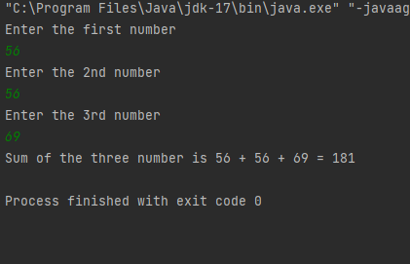

**Python :**

**first_num = int(input("Enter the 1st number : "))**

**second_num = int(input("Enter the 2nd number : "))**

**third_number = int(input("Enter the 3rd number : "))**

**sum_of_numbers = first_num+second_num+third_number**

**# Printing using Python String formatting ,also known as String  interpolation**

**print(f"Sum of three numbers is : {first_num} + {second_num} + {third_number} = {sum_of_numbers}")**

**output:**

